**Category 6 Connection Box**

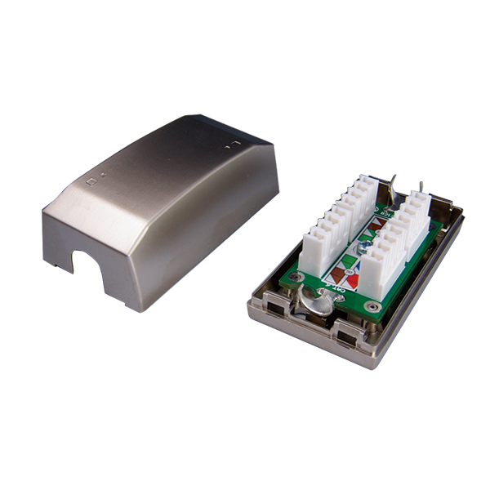

Female to female in-line coupler offer two types - cable extension type and panel mount type, compact housing and great performance. Panel mount type can be used with series I flush mount wall plates.

**Ordering Information**

|  |  |
| --- | --- |
| **Part No.** | **Description** |
| **SJ01P600-XX** | Cat.6 KRONE/110 IDC connection box, Unshielded |
| **SJ01P6S0** | Cat.6 KRONE/110 IDC connection box, Shielded |

***“XX” = Color choices – Ivory (IV), White (WH).***